**Tugas Individu 06**



**Mata Kuliah :** Matematika Diskrit

**Dosen Pengampu :** Brian Sebastian Salim, S.Kom., M.T.I.

**Batas Pengumpulan :** Jumat, 12 Mei 2023; 17.00 WIB

**Nama Mahasiswa** : Richard Marcell

**NIM** : 22100001

**SOAL:**

Gunakan logic.ly (website) untuk mengerjakan soal-soal aljabar Boolean dalam bentuk gerbang logika berikut ini!

Ketentuan:

p, q, r, dan s merupakan saklar lampu. Tentukan output nya (di ujung kanan rangkaian berikan lampu) apakah lampu menyala atau mati, untuk ke-5 rangkaian gerbang logika di bawah ini jika:

* p saklar on
* q saklar off
* r saklar on
* s saklar off

Tuliskan juga pembuktiannya dalam bentuk table kebenaran (0 = off, 1 = on)

1. 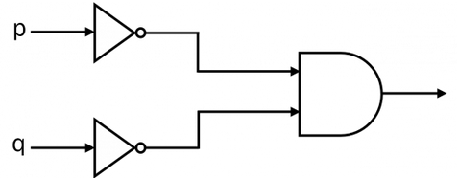
2. 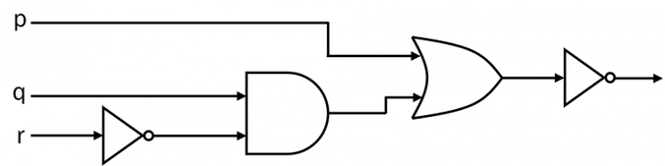
3. 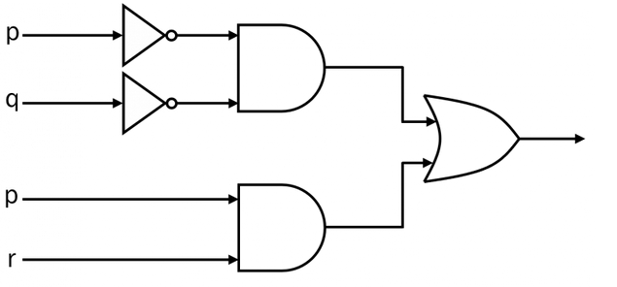
4. 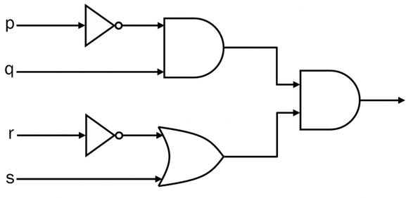
5. 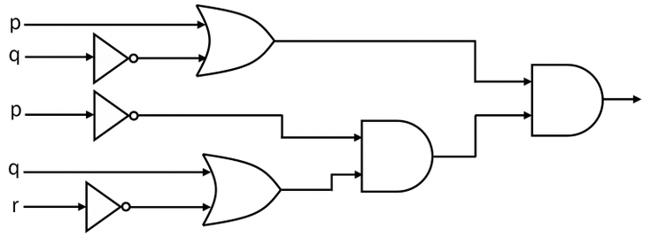

**JAWABAN:**

1. Hasil Gambar Nomor 1

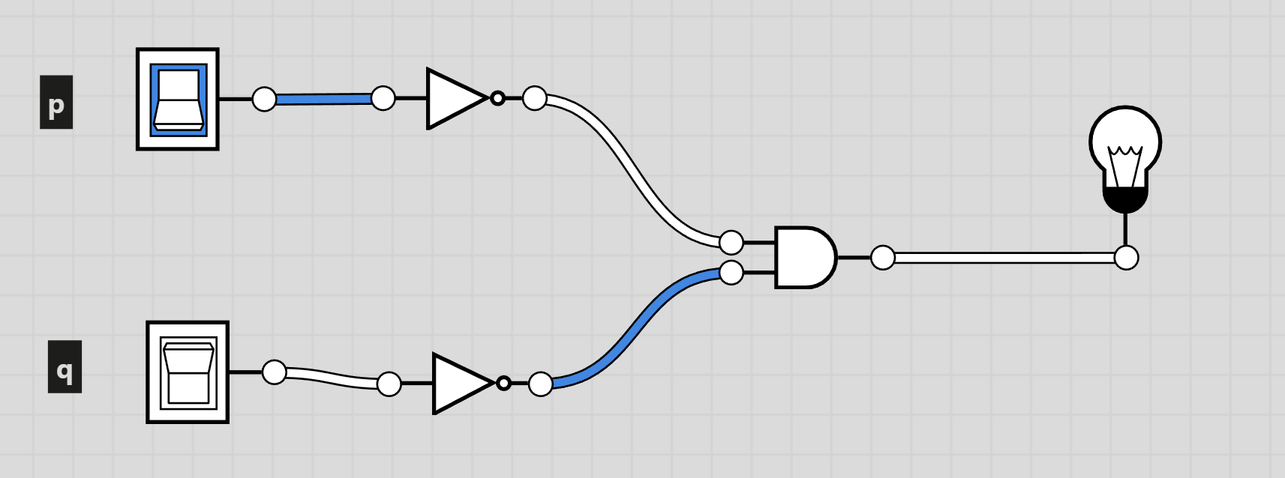

**Tabel Kebenaran**

|  |  |  |  |  |
| --- | --- | --- | --- | --- |
| **p** | **q** | **~p** | **~q** | **~p ^ ~q** |
| 1 | 0 | 0 | 1 | 0 |

1. Hasil Gambar Nomor 2

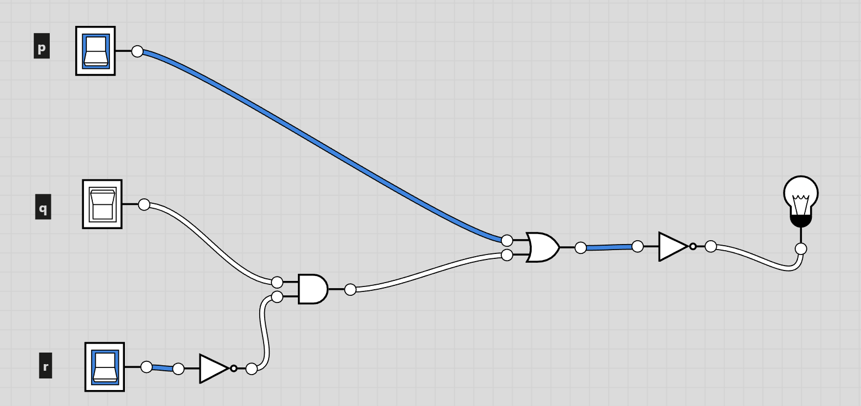

**Tabel Kebenaran**

|  |  |  |  |  |  |  |
| --- | --- | --- | --- | --- | --- | --- |
| **p** | **q** | **r** | **-r** | **q ^ ~r** | **p v (q^~r)** | **~(p v (q^~r))** |
| 1 | 0 | 1 | 0 | 0 | 1 | 0 |

1. Hasil Gambar Nomor 3

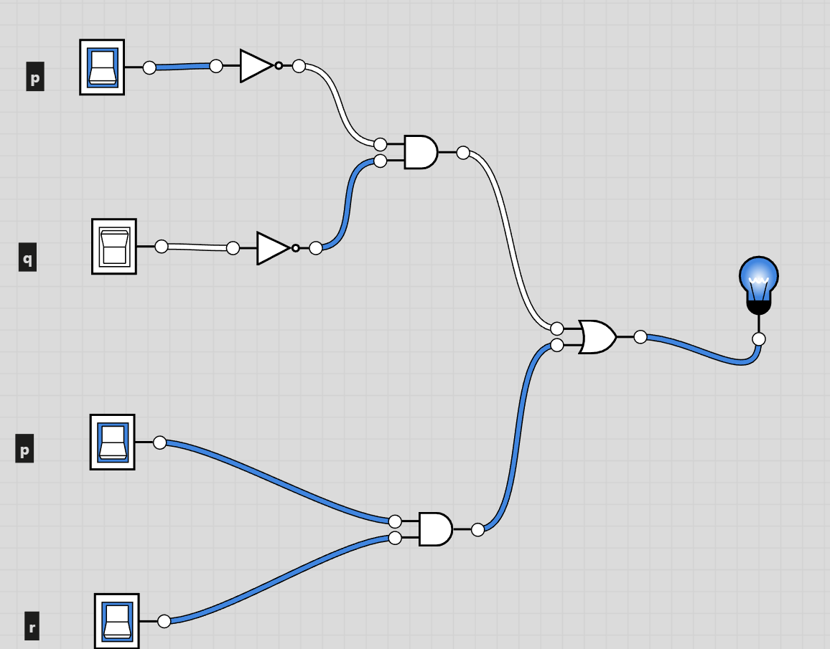

**Tabel Kebenaran**

|  |  |  |  |  |  |  |  |
| --- | --- | --- | --- | --- | --- | --- | --- |
| **p** | **q** | **r** | **~p** | **~q** | **~p ^ ~q** | **p ^ r** | **(~p ^ ~q) v (p ^ r)** |
| 1 | 0 | 1 | 0 | 1 | 0 | 1 | 1 |

1. Hasil Gambar Nomor 4

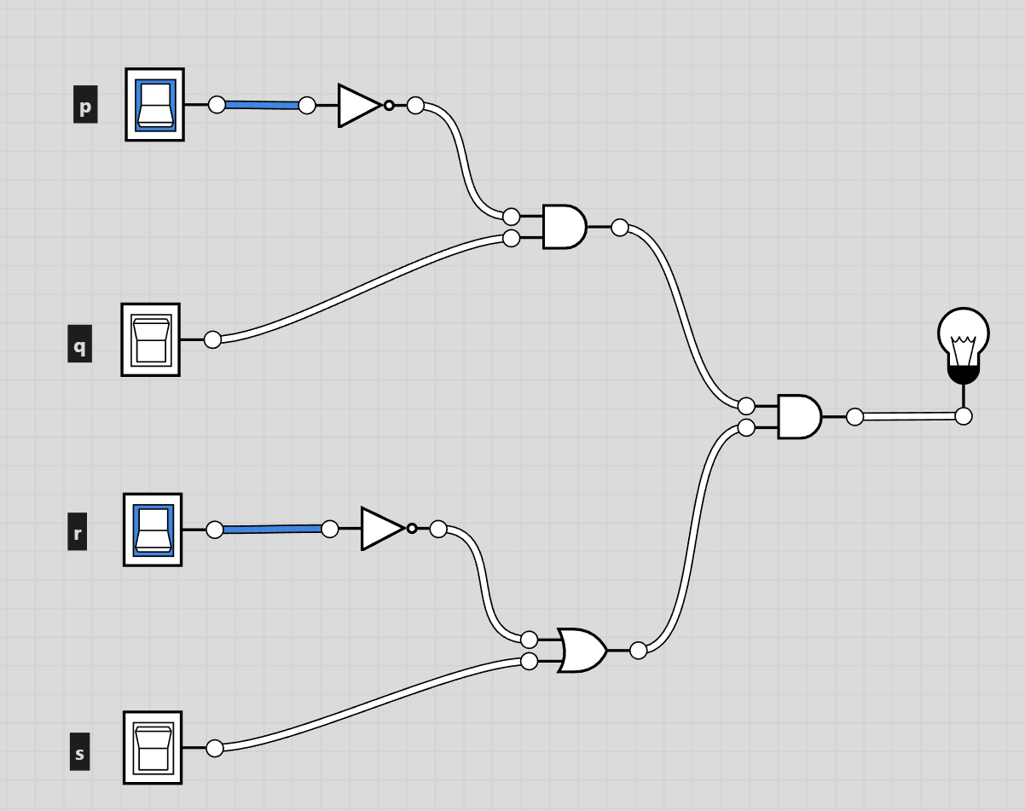

**Tabel Kebenaran**

|  |  |  |  |  |  |  |  |  |
| --- | --- | --- | --- | --- | --- | --- | --- | --- |
| **p** | **q** | **r** | **~p** | **~r** | **s** | **~p ^ q** | **~r v s** | **(~p ^ q) ^ ~r v s** |
| **1** | **0** | **1** | **0** | **0** | **0** | **0** | **0** | **0** |

1. Hasil Gambar Nomor 5

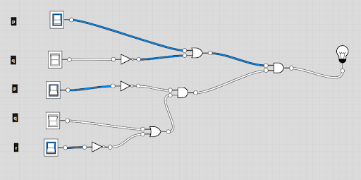

**Tabel Kebenaran**

|  |  |  |  |  |  |  |  |  |  |
| --- | --- | --- | --- | --- | --- | --- | --- | --- | --- |
| **p** | **q** | **r** | **~p** | **~q** | **~r** | **p v ~q** | **q v ~r** | **~p ^ (q v ~r)** | **(p v ~q) ^ (~p ^ (q v ~r))** |
| 1 | 0 | 1 | 0 | 1 | 0 | 1 | 0 | 0 | 0 |